**12 ATAR Human Biology**

**ATHBY Task 3:**

Endocrine and Nervous

System Test

**Weighting 3%**

**Time: 60 minutes**

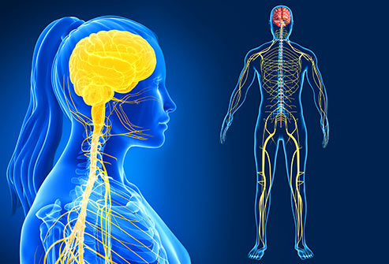

Multiple Choice: 20 marks

Short Answer: 25 marks

Extended Answer: 20 marks

**TOTAL 65 MARKS**

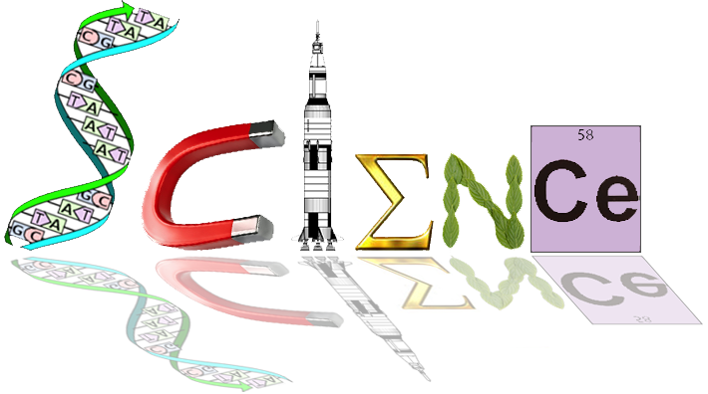

**Multiple Choice Section: (20 marks)**

1. The cerebral cortex is mainly concerned with which of the following?
2. connecting the left and right hemispheres
3. conscious sensory awareness and voluntary movement
4. control of the endocrine system
5. control of both the parasympathetic and sympathetic nervous systems
6. Which of the following statements concerning a spinal reflex is NOT correct?
7. it is a rapid process
8. it is involuntary
9. it can bypass the brain
10. it can occur in a different manner each time
11. Within the nervous system there are special structures that help to protect the system from injury. The name of the membranes that surround the central nervous system is the:
12. meniscus
13. meninges
14. medulla
15. myelin
16. People who have suffered physical damage to the cerebellum would be expected to show symptoms such as:
17. a low intelligence
18. uncoordinated jerky movements
19. a lack of autonomic nervous system functioning
20. no memory
21. The autonomic nervous system is responsible for which of the following?
22. sleeping and waking cycles
23. voluntary smooth muscle functioning
24. involuntary smooth muscle functioning
25. voluntary skeletal muscle functioning

The information below describes changes that occur within the human body

1. dilation of pupils
2. increased salivation
3. increased secretion from the sweat glands
4. increased heart rate
5. decreased levels of adrenalin
6. dilation of blood vessels in the skeletal muscle
7. Which of the changes described above occur as a result of stimulation of the sympathetic nervous system?
8. i,iii,v and vi
9. i, ii, iii and v
10. i, iii, iv and vi
11. ii, iv, v and vi
12. The effectors associated with negative feedback models are:
13. the nervous and endocrine systems
14. the body fluids
15. glands and muscles
16. all body tissues
17. The ________ contains centres for heartbeat, breathing, and blood pressure.:
18. hypothalamus
19. cerebellum
20. medulla oblongata
21. spinal cord

1. Which of the following is NOT produced by the anterior pituitary gland?
2. antidiuretic hormone
3. thyroid stimulating hormone.
4. growth hormone.
5. prolactin.
6. Which of the following statements is true of hormones?
7. Hormones are stable, long-lasting chemicals released from glands
8. All hormones are lipid-soluble
9. Hormones are chemical messengers that are released into interstitial fluid
10. Hormones are short-lasting and function in localised areas of the body
11. When the hormone cortisol reaches a target cell, it enters the cell and combines with a receptor protein inside the cell. The combined substance enters the nucleus, where it activates genes to produce a protein. Thus, cortisol is a:
12. water soluble amine
13. water soluble steroid
14. lipid soluble amine
15. lipid soluble steroid

12 The nervous and endocrine systems are both important in the coordination of body

functions. However, there are several differences in their modes of action.

Which one of the following statements concerning these differences is correct?

1. Hormones take milliseconds to reach their target, whereas nerve impulses take

longer, ranging from seconds to hours.

1. Once they have reached their target, hormonal responses last for longer periods of time than nervous responses.
2. Hormonal responses involve electrochemical changes, whereas nervous

responses involve only chemical changes.

1. Nervous responses are usually more general and widespread than hormonal

responses.

Question 13 refers to the diagram below.



13 The region labelled ‘X’ represents a

1. ganglion.
2. node of Ranvier.
3. neuromuscular junction.
4. synapse.

Question 14 and 15 refers to the diagram below.

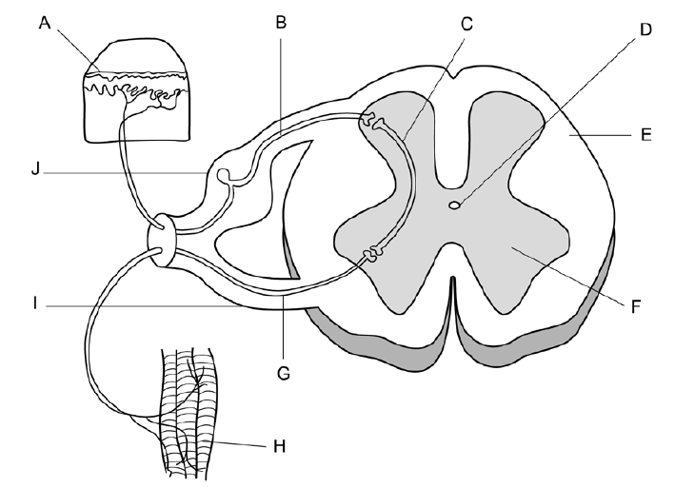

1. Which of the following statements relating to the above diagram of the spinal reflex arc is correct?
2. A stimulus is detected by the receptors labelled ‘H’ and transmitted through the sensory neuron labelled ‘G’
3. The motor neuron is labelled ‘G’ and is located in the ventral root labelled ‘I’
4. The interneuron is labelled ‘C’ and is located in the white matter labelled ‘F’
5. A stimulus is detected by the receptors labelled ‘A’ and transmitted through the motor neuron labelled ‘B’
6. The neuron labelled ‘B’ in the diagram can be described as an:
7. afferent neuron carrying information toward the spinal cord
8. efferent neuron carrying information away from the spinal cord
9. efferent neuron carrying information toward the spinal cord
10. afferent neuron carrying information away from the spinal cord

Question 16 refers to the diagram below

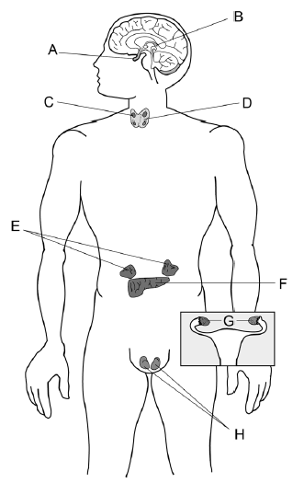

1. Which of the following options correctly matches a label with a hormone it secretes:
2. A – melatonin
3. D = growth hormone
4. E = adrenaline
5. H = oxytocin
6. In a person with normal thyroid function, low levels of thyroxin in the blood would result in:
7. increased metabolic rate and would involve feedback from the anterior pituitary
8. increased metabolic rate and would involve feedback from the posterior pituitary
9. decreased metabolic rate and would involve feedback from the anterior pituitary
10. decreased metabolic rate and would involve feedback from the posterior pituitary
11. Throughout the peripheral nervous system _______________ cells produce myelin, whereas ___________________ provide myelin in the central nervous system.
12. astrocytes, Schwann
13. Shwann, oligodendrocytes
14. Shwann, neurilemma
15. neurilemma, astrocytes
16. Which of the following structures is the smallest?
17. nerve
18. neuron
19. nerve fibre
20. ganglion
21. At resting potential, the ion distribution inside and outside of a neuron is such that __________ ions are most abundant on the outside of the cell, while __________ ions are most abundant on the inside of the cell.
22. potassium; sodium
23. sodium; potassium
24. calcium; phosphate
25. sulfate; potassium

**Short Answer: (25 marks)**

**Answer All Questions.**

1a Complete the following table providing two differences between the autonomic and the somatic divisions. (4 marks)

|  |  |
| --- | --- |
| **Division of Nervous system** | **Differences between the Divisions** |
| Autonomic NS | Involuntary/ 2 neurotransmitters –noradrenaline, acetylcholine/  Pathway from CNS to organ consists of 2 neurones |
| Effectors smooth muscle, glands, cardiac muscle |
| Somatic NS | Voluntary/ neurotransmitter acetylcholine/Pathway from CNS to skeletal muscles 1 neurone |
| Effectors skeletal muscle |

b Explain why scientists classify neurons into both functional and structural types.

(2 marks)

Structural- relates to appearance of neuron eg. Location of cell body/number of extensions

Useful when viewing neurons (1)

Functional- relates to structure neuron conducts information to sensory/afferent

Motor/efferent

Useful when communicating role of pathway (1)

One of the types of neurons involved in the reflex arc is classified as unipolar. The

diagram below shows the general structure of a unipolar neuron.



c Name the type of neuron that is unipolar. (1 mark)

Sensory

d Explain why it is classified as unipolar. (1 mark)

has one extension, an axon / dendrites and axon are continuous/ cell bodies lies to the side

**Total 8 marks**

2, The diagram below shows the relationship between the hypothalamus and the pituitary gland.





a Describe the process leading to secretion of hormones from the anterior lobe into the bloodstream. (3 marks)

Hypothalamus act as a receptor (1)

Hypothalamus secretes releasing and inhibiting factors-carried via blood to ALP (1)

Stimulated ALP to release hormones (1)

b Explain why the posterior lobe is **not** considered to be a true endocrine gland.

(2 marks)

Antidiuretic & Oxytocin produced in special nerve cells in hypothalamus. (1) Hormones travel down nerve extension to PLP and are stored ready for release. (1)

c Use the two hormones released by the anterior lobe of the pituitary gland to complete the following table**.** (4 marks)

|  |  |  |
| --- | --- | --- |
| **Hormone** | **Target Cells/Organ** | **Function** |
| Adrenocorticotrophic  hormone (ACTH) | Adrenal cortex (1) | Secretion of hormones from the adrenal cortex  (1) |
| Luteinizing hormone  (LH) | Ovaries  (1)  testes | Ovulation and maintenance of corpus luteum  Secretion of testosterone (1) |

**Total 9 marks**

Question 3 refers to the following diagram.



3a. Alzheimer’s disease is a form of dementia that can cause memory loss, confusion and mood swings. Given these symptoms of Alzheimer’s disease, which part of the brain (labelled A-D) above would you expect to be most affected by this disease?

A

(1 mark)

b Although different diseases, Alzheimer’s disease and Parkinson’s disease are similar in that they both affect the brain. There are also similarities in the causes and effects of these diseases. State one such similarity between Alzheimer’s disease and Parkinson’s disease.

1. mark)

Caused by deficiency of neurotransmitters - P dopamine A acetylcholine or effect some memory loss in elderly

c Complete the table below, describing 3 key differences between the nervous and endocrine system. (6 marks)

|  |  |  |
| --- | --- | --- |
| **Characteristic** | **Nervous System** | **Endocrine System** |
| Nature of Message | Electrochemical/ nerve Impulses/neurotransmitter | Chemical transmission/hormones |
| Cells affected | Muscle and gland cells; other neurons | All body cells |
| Type of response | Usually local and specific | May be very general and widespread |

**Total 8 marks**

**SECTION C: Extended Answer 20 marks**

Answer each part of the following question on the line paper provided. Responses could include clearly **labelled tables** and **graphs**; **clearly labelled diagrams with explanatory notes;** **lists of points with linking sentences** and **annotated flow diagrams with introductory notes.**

1. Aspirin helps reduce pain because it inhibits the synthesis of neurotransmitters called prostaglandins.

a. Outline the events involved in an electrochemical nerve impulse travelling along an unmyelinated nerve fibre. 8 marks

One mark each for any 8 of following points

* + In a resting neuron there is a net +ive charge on outside membrane and –ive
  + charge on inside –potential difference -70mV. Membrane polarised.
  + High Concentration of Na+ on outside, high concentration of K+ on inside. Large
  + -ively charged organic molecules are also located on the inside.
  + Na+ are pumped out by the membrane and K+ are pumped in. The Na+-K+ pump maintains the potential difference of -70mV when the neuron is resting
  + Protein channels in the membrane allow Na+ out and K+ in/The channels allow potassium ions to leak out more quickly than sodium ion can leak in. This ensures a negative membrane potential in resting neuron
  + When an impulse travels along the neuron sodium channels are opened
  + Sodium ions rush into the neuron causing a switch in the membrane potential – it becomes –ive on the outside and +ive on the inside-+30mV
  + A small depolarisation on the edge of the impulse causes more sodium channels to open in front of the impulse – this causes the spike in the impulse to move down the neuron
  + If sufficient depolarisation -15mV occurs- causes a wave of depolarisation- the impulse self propagates
  + Depolarisation also causes the K+ channels to open- K+ leaves the neuron moving rapidly out of the neuron causing repolarisation of membrane
  + The impulse moves in one direction along the neuron-Na+ channels cannot immediately reopen. This is called the refractory period. Depolarisation can not occur
  + Depolarisation occurs all along the fibre.

b. Explain how this differs in a myelinated fibre. 4 marks

Unmyelinated is continuous/flows along membrane (1)

Myelinated action potential jumps from one node to another/deplarisation occurs at Nodes of Ranvier (1)

Known as salutatory conduction (1)

Faster than unmyelinated (1)

When an impulse reaches the end of an axon it cannot travel any further as it has reached a gap called a synapse.

c. Explain how an impulse can travel from one to neurone the next neurone; include the generalised role of neurotransmitters. 8 marks

1 mark for each point

* A synapse is the junction between two neurones,
* Nerve impulse transmission occurs because special neurotransmitter chemicals are released into the tiny gap (the synaptic cleft), which separates the two nerve cells.
* When impulse reaches axon ending Ca2+ is released
* Vesicles containing neurotransmitter move towards pre-synaptic membrane
* Vessicles join membrane and release neurotransmitter into synaptic cleft/exocytosis of neurotransmitters
* They diffuse across gap/cleft and attach to receptors on the dendrites of the next neurone
* This causes Na+ channels to open- depolarisation of dendrites
* Impulse continues along neurone

Name:_________________________________________________________________________________________________________________________________________________________________________________________________________________________________________________________________________________________________________________________________________________________________________________________________________________________________________________________________________________________________________________________________________________________________________________________________________________________________________________________________________________________________________________________________________________________________________________________________________________________________________________________________________________________________________________________________________________________________________________________________________________________________________________________________________________________________________________________________________________________________________________________________________________________________________________________________________________________________________________________________________________________________________________________________________________________________________________________________________________________________________________________________________________________________________________________________________________________________________Name:__________________________________________________________________________________________________________________________________________________________________________________________________________________________________________________________________________________________________________________________________________________________________________________________________________________________________________________________________________________________________________________________________________________________________________________________________________________________________________________________________________________________________________________________________________________________________________________________________________________________________________________________________________________________________________________________________________________________________________________________________________________________________________________________________________________________________________________________________________________________________________________________________________________________________________________________________________________________________________________________________________________________________________________________________________________________________________________________________________________________________________________________________________________________________________________________________________________________________________Name:__________________________________________________________________________________________________________________________________________________________________________________________________________________________________________________________________________________________________________________________________________________________________________________________________________________________________________________________________________________________________________________________________________________________________________________________________________________________________________________________________________________________________________________________________________________________________________________________________________________________________________________________________________________________________________________________________________________________________________________________________________________________________________________________________________________________________________________________________________________________________________________________________________________________________________________________________________________________________________________________________________________________________________________________________________________________________________________________________________________________________________________________________________________________________________________________________________________________________________Name___________________________________________________________________________________________________________________________________________________________________________________________________________________________________________________________________________________________________________________________________________________________________________________________________________________________________________________________________________________________________________________________________________________________________________________________________________________________________________________________________________________________________________________________________________________________________________________________________________________________________________________________________________________________________________________________________________________________________________________________________________________________________________________________________________________________________________________________________________________________________________________________________________________________________________________________________________________________________________________________________________Name___________________________________________________________________________________________________________________________________________

________________________________________________________________________________________________________________________________________________________________________________________________________________________________________________________________________________________________________________________________________________________________________________________________________________________________________________________________________________________________________________________________________________________________________________________________________________________________________________________________________________________________________________________________________________________________________________________________________________________________________________________________________________________________________________________________________________________________________________________________________________________________________________________________________________________________________________________________________________________________________________________________________________________________________________________________________________________________________________________________________________

**YEAR 12 ATAR HUMAN BIOLOGY**

Task 3:

Endocrine and Nervous System Test

SCORES:

MC: /20

SA: /25

EA: /20

TOTAL: /65

_______ %

**NAME:_____________________________**

**TEACHER:__________________________**

**DATE:______________________________**

**Section A: Multiple choice**

Answer all questions by circling the most correct answer on the multiple choice answer sheet.

1. a b c d 18. a b c d

2. a b c d 19. a b c d

3. a b c d 20. a b c d

4. a b c d 21. a b c d

5. a b c d 22. a b c d

6. a b c d 23. a b c d

7. a b c d 24. a b c d

8. a b c d 25. a b c d

9. a b c d 26. a b c d

10. a b c d 27. a b c d

11. a b c d 28. a b c d

12. a b c d 29. a b c d

13. a b c d 30. a b c d

14. a b c d

15. a b c d

16 a b c d

17 a b c d